Program demonstrates the Updatable ResultSet.

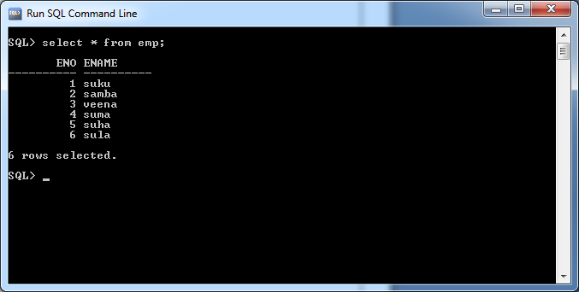

import java.sql.Connection;

import java.sql.DriverManager;

import java.sql.PreparedStatement;

import java.sql.ResultSet;

import java.sql.SQLException;

public class Sample {

public static String qur="select eno,ename from emp";

public static void main(String[] args) throws InterruptedException {

try(Connection con=DriverManager.getConnection("jdbc:oracle:thin:@localhost:1521:xe","sukumar","sukumar");

PreparedStatement s=con.prepareStatement(qur,ResultSet.TYPE_SCROLL_SENSITIVE,ResultSet.CONCUR_UPDATABLE);

){

if(s!=null) {

ResultSet r=s.executeQuery();

r.moveToInsertRow();

r.updateInt(1, 7);

r.updateString(2, "subbarao");

r.insertRow();

r.absolute(6);

r.updateString(2, "sulakshmi");

r.updateRow();

}

}

catch(SQLException e) {

System.out.println(e.getMessage());

}

}

}

